

CAPSTONE PROJECT REPORT
Report 3 – Software Requirement Specification

A2MaTeX - Android Device Automation and Distribution Platform

INSTRUCTOR: PHAM QUANG KHANG
CLASS: SEP490_G52
Team Members:
- Ly Ngoc Mai | HE190089
- Sy Thi Quynh Nga | HE190134
- Tran Tien Duc | HE180366
- Tran Xuan Dong | HE182253
- Tran Van Khuyen | HE187268

– Hanoi, Aug 2026 –
Table of Contents
Change Log 4
Definition and Acronyms 5
I. Overall Requirements 5
1. Context Diagram 5
2. Main Business Flow 5
2.1 Candidate Self-Service (BF-01) 5
2.2 End-to-End Recruitment (BF-02) 5
2.3 Business Flow Name (Code) 6
3. Conceptual Data Model 6
3.1 Entity Relationship Diagram 6
3.2 Entity Descriptions 6
3.3 Data Business Rules 7
4. User Requirements 8
4.1 Actors 8
4.2 Use Cases (UC) 8
4.3 Use Case Diagrams 9
4.4 Permission Matrix 9
5. System Functionalities 10
5.1 Screen Inventory 10
5.2 External API Inventory 10
5.3 Background Job Inventory 11
II. Use Case Specifications 11
1. <<Feature Name1>> 11
1.1 UC Name1 11
1.2 Login System 12
1.3 UC Name2 12
2. Xyz Feature 12
III. Functional Requirements 13
1. Authentication 13
1.1 User Register 13
1.2 User Login 13
2. Marketplace 13
2.1 Market 13
2.2 Tool Detail 13
3. System Administration 14
3.1 System Settings 14
3.2 User Management 15
4. Feature NameN 15
5. Background Job Inventory 15
5.1 Unlock Expired Locked Accounts (JOB-01) 15
5.2 Clean Up Old Audit Log Entries (JOB-02) 15
6. External API Inventory 16
6.1 HTTP Method: URL pattern (API-ID) 16
6.2 VnPay Webhook (API-02) 16
6.3 SePay Webhook (API-03) 16
IV. Non-Functional Requirements 16
1. External Interfaces 16
2. Quality Attributes 16
2.1 Usability 16
2.2 Performance 17
2.3 Security 17
V. Requirement Appendix 17
1. Business Rules 17
2. System Messages 18
3. Other Requirements 18

Change Log
Date | A*  M, D | In charge | Change Description
27/9 | A | NgaSTQ | Add Screen Inventory for Webmarket and Desktop client
*A - Added M - Modified D - Deleted

Definition and Acronyms
[Fill all the definitions, acronyms,… used within the whole project in the table format as below]
Acronym | Definition
COS | Cafeteria Ordering System
…

I. Overall Requirements

1. Context Diagram
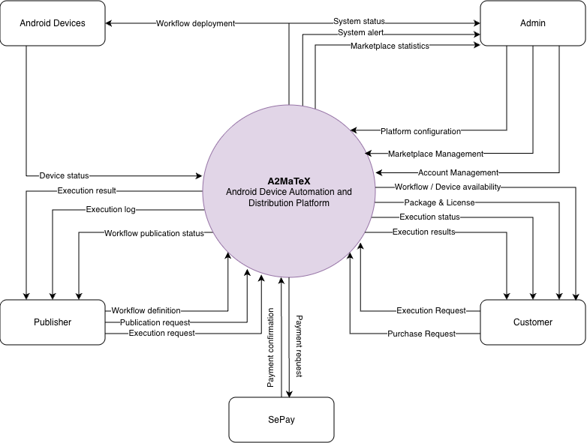
Figure 1: Context diagram

2. Main Business Flow
[List all flows with swimlane diagrams as samples below].

2.1 Candidate Self-Service (BF-01)
Trigger: Candidate creates an account.
End condition: Candidate has seen the final outcome of all applications.
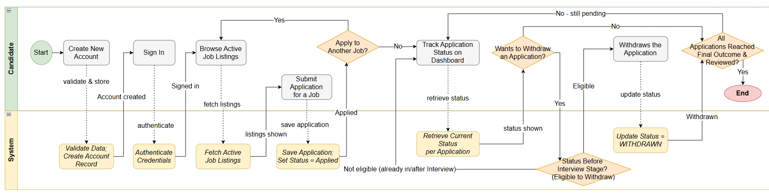

2.2 End-to-End Recruitment (BF-02)
Trigger: HR Manager decides to open a new position and creates a job posting.
End condition: Candidate status reaches HIRED or REJECTED (both terminal).

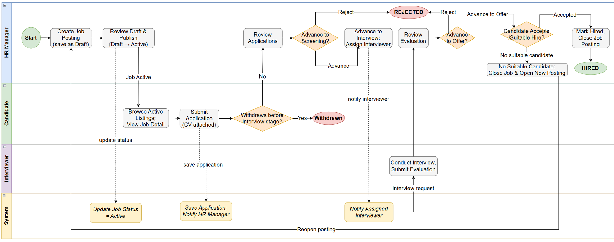

2.3 Business Flow Name (Code)
…

3. Conceptual Data Model

3.1 Entity Relationship Diagram
[Provide the ERD using the Crow-Foot notation and the entity descriptions as below. Relationship labels are business verb-ing]
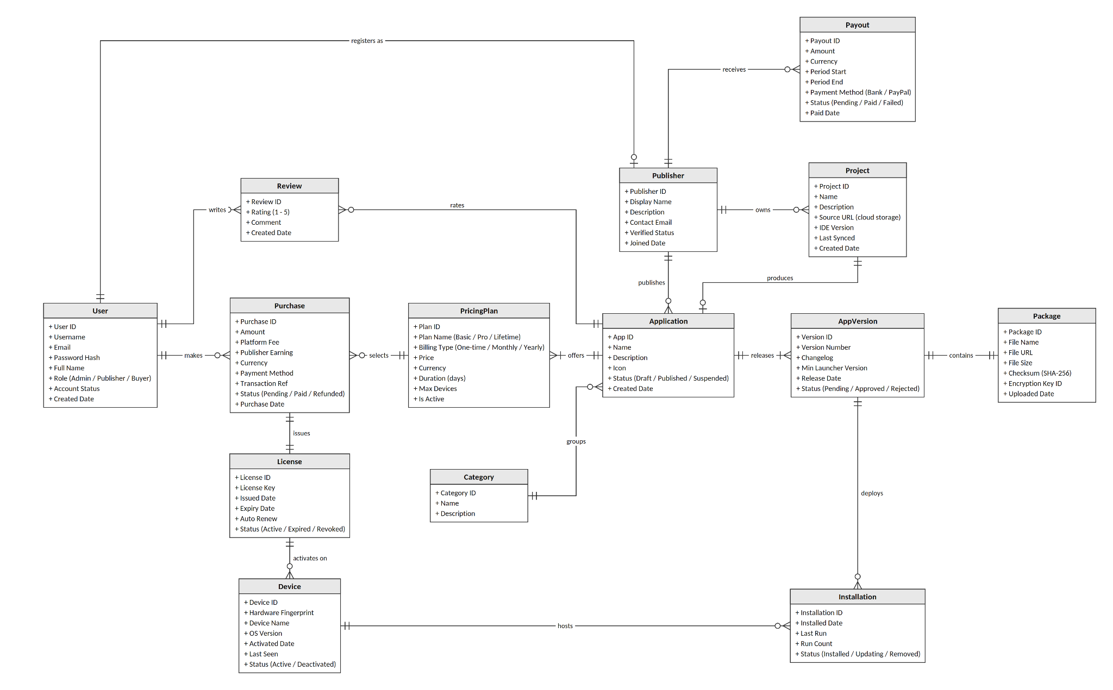

3.2 Entity Descriptions
[Provide one block per entity with descriptions and key business attributes only.]v
Entity: User
Field | Value
Purpose | Every person with an account in the system, regardless of role; the login subject for the Web, the IDE and the Launcher.
Key business attributes | Username, Email, Password Hash, Full Name, Role (Admin / Publisher / Buyer), Account Status, Created Date
Business identity | Username unique across the entire system. Email unique across the entire system. A User has at most one Publisher profile.
Status / lifecycle | Active (normal) · Inactive (deactivated by Admin — cannot sign in, issued licenses are kept) · Locked (temporary — after 5 failed sign-in attempts, auto-unlocked after 15 minutes)
Entity: Publisher
Field | Value
Purpose | Seller profile of a User who wants to publish apps; holds the public display information, verification status and the public key used to sign packages. Owns Projects and Applications and receives Payouts.
Key business attributes | Display Name, Description, Contact Email, Verified Status, Joined Date, Public Key (package signing).
Business identity | One-to-one with User (each User has at most one Publisher). Display Name unique across the marketplace.
Status / lifecycle | Unverified (newly registered, cannot publish) → Verified (identity and payout account confirmed by Admin) → Suspended (policy violation; apps on sale are hidden, no new versions accepted); Suspended → Verified when Admin lifts the suspension.
Entity: Project
Field | Value
Purpose | Automation workflow source created by a Publisher in the IDE and stored on the server for syncing between machines; the origin of an Application on first publish.
Key business attributes | Automation workflow source created by a Publisher in the IDE and stored on the server for syncing between machines; the origin of an Application on first publish.
Business identity | Name unique within a Publisher. A Project produces at most one Application.
Status / lifecycle | No lifecycle status. A Project exists until the Publisher deletes it; deleting a Project does not affect the published Application or its AppVersions.
Entities: Payout
[Add one block per additional entity following the same structure.]
Field | Value
Purpose | Periodic revenue payment to a Publisher, aggregating the Publisher Earning of all Paid (non-Refunded) Purchases in the period.
Key business attributes | Amount, Currency, Period Start, Period End, Payment Method (Bank / PayPal), Status, Paid Date
Business identity | Exactly one Payout per (Publisher, Period Start – Period End); periods do not overlap.
Status / lifecycle | Pending (calculated, awaiting transfer) → Paid (terminal) or Failed (transfer error; may be recreated → Pending)

Entities: Category
[Add one block per additional entity following the same structure.]
Field | Value
Purpose | Classification of Applications on the marketplace, managed by Admin; used for browsing and search.
Key business attributes | Name, Description
Business identity | Name unique. Each Application belongs to exactly one Category.
Status / lifecycle | No status (reference data). Can only be deleted when no Application belongs to it.
Entities: Application
[Add one block per additional entity following the same structure.]
Field | Value
Purpose | An automation product sold by a Publisher on the marketplace; the unit that buyers browse, purchase and review. Has many AppVersions and many PricingPlans.
Key business attributes | Name, Description, Icon, Status, Created Date; owning Publisher; Category; source Project
Business identity | Name unique within a Publisher. App ID is written into the manifest of every package. Produced by at most one Project.
Status / lifecycle | Draft (no Approved AppVersion, not listed) → Published (at least one Approved AppVersion and one Active PricingPlan) → Suspended (locked by Admin for violation: hidden from the marketplace, no new versions accepted, existing buyers can still run it); Suspended → Published when Admin lifts the suspension
Entities: PricingPlan
[Add one block per additional entity following the same structure.]
Field | Value
Purpose | A price option of an Application: billing model, price, duration and device limit; what the buyer selects when purchasing or renewing.
Key business attributes | Plan Name, Billing Type (One-time / Monthly / Yearly), Price, Currency, Duration (days), Max Devices, Is Active
Business identity | Plan Name unique within an Application. Price and terms are snapshotted into the Purchase and License at checkout; editing a plan does not affect issued licenses.
Status / lifecycle | Active (on sale) ↔ Inactive (withdrawn; existing Purchases and renewals of the plan remain valid). A plan with Purchases is never deleted.
Entities: AppVersion
[Add one block per additional entity following the same structure.]
Field | Value
Purpose | A specific release of an Application built by the IDE; the unit that Admin reviews and the Launcher installs or updates.
Key business attributes | Version Number (SemVer), Changelog, Min Launcher Version, Release Date, Status
Business identity | Plan Name unique within an Application. Price and terms are snapshotted into the (Application, Version Number) unique; Version Number must be greater than the latest Approved version. An Application has at most one Pending AppVersion at a time.
Status / lifecycle | Pending (uploaded, awaiting review) → Approved (released; downloadable by the Launcher) or Rejected (terminal, with reason; the Publisher uploads a new version). The Publisher may withdraw a Pending version.

Entities: Package
[Add one block per additional entity following the same structure.]
Field | Value
Purpose | The physical .apkg file of an AppVersion: encrypted and signed workflow content stored on object storage; what the Launcher downloads and verifies before installing.
Key business attributes | File Name, File URL, File Size, Checksum (SHA-256), Encryption Key ID, Uploaded Date
Business identity | One-to-one with AppVersion. Checksum unique. Immutable after upload: any content change is a new AppVersion.
Status / lifecycle | No status of its own, follows the AppVersion. The file is removed from storage 30 days after its AppVersion is Rejected.
Entities: Purchase
[Add one block per additional entity following the same structure.]
Field | Value
Purpose | A buyer's transaction for one PricingPlan (new purchase or renewal); the financial record and the basis for the Publisher's Payout.
Key business attributes | Amount, Platform Fee, Publisher Earning, Currency, Payment Method, Transaction Ref, Status, Purchase Date
Business identity | Transaction Ref unique (issued by the payment gateway). A new purchase issues exactly one License; a renewal purchase is attached to an existing License.
Status / lifecycle | Pending (order created, awaiting payment; auto-cancelled after 24 hours) → Paid (gateway webhook succeeded; License issued or renewed) → Refunded (money returned; License becomes Revoked)
Entities: License
[Add one block per additional entity following the same structure.]
Field | Value
Purpose | A buyer's right to use one Application, issued from a Purchase; what the Launcher activates and validates before allowing download and execution.
Key business attributes | License Key, Issued Date, Expiry Date, Auto Renew, Status; Max Devices snapshotted from the PricingPlan
Business identity | License Key unique across the entire system, stored as SHA-256. Bound to exactly one originating Purchase and one User.
Status / lifecycle | Pending (Purchase not yet paid) → Active → Expired (plans with a Duration only; renewal returns it to Active); Active or Expired → Revoked (terminal: refund, Admin action, fraud). Details in section 3.2.4.2.

Entities: Device
[Add one block per additional entity following the same structure.]
Field | Value
Purpose | A buyer's machine on which a License has been activated, identified by a hardware fingerprint to limit how many machines share one license.
Key business attributes | Hardware Fingerprint, Device Name, OS Version, Activated Date, Last Seen, Status
Business identity | (License, Hardware Fingerprint) unique. The number of Active Devices per License never exceeds Max Devices.
Status / lifecycle | Active → Deactivated (removed by the buyer or Admin, or License Revoked); Deactivated → Active on re-activation while a slot is free. Buyers may self-deactivate at most 3 times per 30 days.
Entities: Installation
[Add one block per additional entity following the same structure.]
Field | Value
Purpose | Record of an AppVersion installed on a Device; tells the Launcher which machine runs which version, for updates and usage statistics.
Key business attributes | Installed Date, Last Run, Run Count, Status; current AppVersion
Business identity | Each Device has at most one Installation per Application; an update moves the Installation to the new AppVersion instead of creating a new record.
Status / lifecycle | Installed → Updating (downloading or installing a new version) → Installed; Installed → Removed (uninstalled by the buyer or License Revoked); Removed → Installed on reinstall
Entities: Review
[Add one block per additional entity following the same structure.]
Field | Value
Purpose | A buyer's public rating and comment on an Application they purchased; used to compute the average rating on the app page.
Key business attributes | Rating (1–5), Comment, Created Date
Business identity | (User, Application) unique — one editable review per buyer per app. Only Users with a Paid Purchase of the app may review it.
Status / lifecycle | No status. Admin removes reviews that violate policy; the Publisher cannot edit or delete them.

3.3 Data Business Rules
[Rules about data that are not obvious from the ERD. ]
Rule | Description | Enforced On
Unique username | No two users may share the same username, regardless of role. | Account creation and username change
Unique email | No two users may share the same email address. | Account creation and email change
One application per job | A Candidate may not submit a second Application for a job they have already applied to, even if the previous was withdrawn. | Application submission
Application requires active job | A Candidate may only apply for a Job Posting with status Active. | Application submission
Accounts never permanently deleted | User accounts are deactivated, not deleted. All associated data must remain accessible. | Account deactivation
Jobs with applications cannot be deleted | A Job Posting with at least one Application (any status) cannot be deleted — must be Closed instead. | Job deletion
Internal notes are permanent | Once saved, an Internal Note cannot be edited or deleted by anyone. They form an audit trail. | Note creation
Evaluations are permanent | Once an Interviewer submits rating and feedback, neither can be changed by anyone. | Evaluation submission
CV files are access-controlled | CV files must never be accessible via a guessable or publicly shareable link. Access verified by system on every download. | CV file access

4. User Requirements

4.1 Actors
[An actor is someone/something that interacts with the system.
- The only external entities that interact with the system
- ﻿Actors are outside the system and not part of it
- ﻿A user is an individual, whereas an actor represents the role played by all users of the same type
- There are other types of actors in addition to or in place of human actors: external systems, I/O devices, or timers
Following are some questions you might ask to help user representatives identify actors
- Who (or what) is notified when something occurs within the system?
- Who (or what) provides information or services to the system?
- Who (or what) helps the system respond to and complete a task?
This part gives the description of system actors, you can follow the table form as below]
# | Actor | Description
1 | Administrator | Actor description here..
2 | Menu Manager | ..
3 | …

4.2 Use Cases (UC)
[A use case (UC) describes a sequence of interactions between a system and an external actor that results in the actor being able to achieve some outcome of value. The names of use cases are always written in the form of a verb followed by an object. Select strong, descriptive names to make it evident from the name that the use case will deliver something valuable for some user.
Following are some questions you might ask to help user representatives identify use cases
- What will the actor use the system for?
- Will the actor create, store, change, remove, or read data in the system?
- Will the actor need to inform the system about external events or changes?
- Will the actor need to be informed about certain occurrences in the system?
This part describes the use cases following the form of the table as below]
ID | Use Case | Feature | Use Case Description
01 | View Menu | Feature Name1
02 | Order a Meal | Feature Name2
03 | …
…

4.3 Use Case Diagrams
In this section, you need to provide the UC diagram(s) to show the actor-UCs and UC-UC relationships like the sample below. You can have multiple UC diagrams for the system, each diagram is for one human actor or one workflow]

4.3.1 UCs for Guest
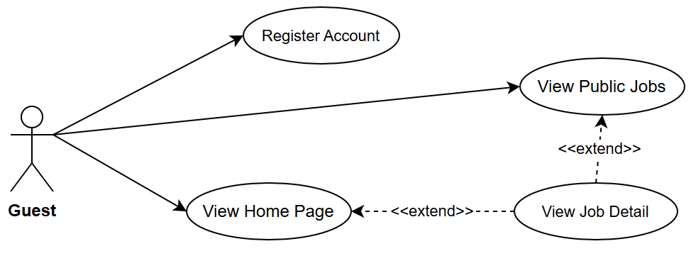

4.3.2 UCs for Candidate
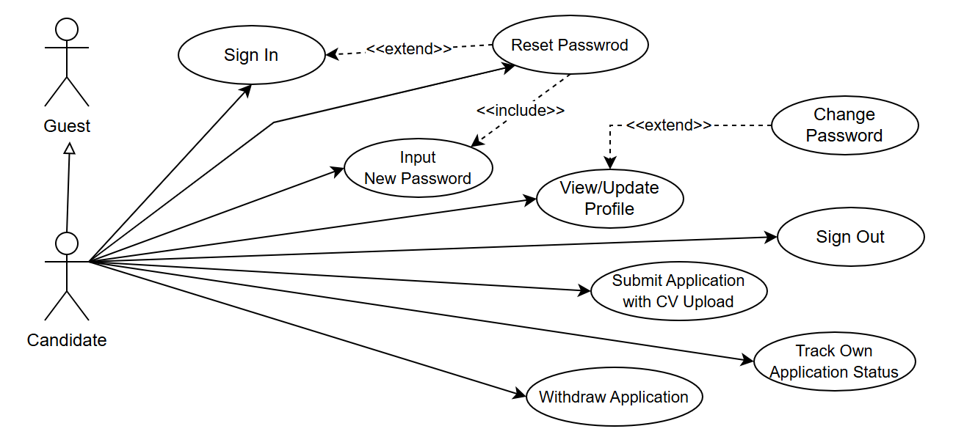

4.3.3 …

4.4 Permission Matrix
Full = unrestricted · Restricted = conditions apply (see footnotes) · No = denied
Entity | Action | Admin | HR Manager | Interviewer | Candidate | Guest
User account | Create | Full | No | No | No | No
User account | Edit / Deactivate | Full | No | No | No | No
User account | Unlock | Full | No | No | No | No
Job posting | Create | Full | Full | No | No | No
Job posting | Edit | Full | Full | No | No | No
Job posting | Delete | Full | Full | No | No | No
Job posting | Change status | Full | Full | No | No | No
Job posting | View (Active only) | Full | Full | Full | Full | Full
Application | Submit | No | No | No | Full | No
Application | View own | No | No | No | Full | No
Application | View all (per job) | Full | Full | Restricted ¹ | No | No
Application | Update status | Full | Full | No | No | No
Application | Withdraw | No | No | No | Full | No
Internal note | Create / View | Full | Full | No | No | No
Interview | Schedule / Assign | Full | Full | No | No | No
Interview | Submit evaluation | Full | Full | Full | No | No
Dashboard | View | Full | Full | No | No | No

5. System Functionalities

5.1 Screen Inventory

5.1.1 Marketplace web

Screen Flow
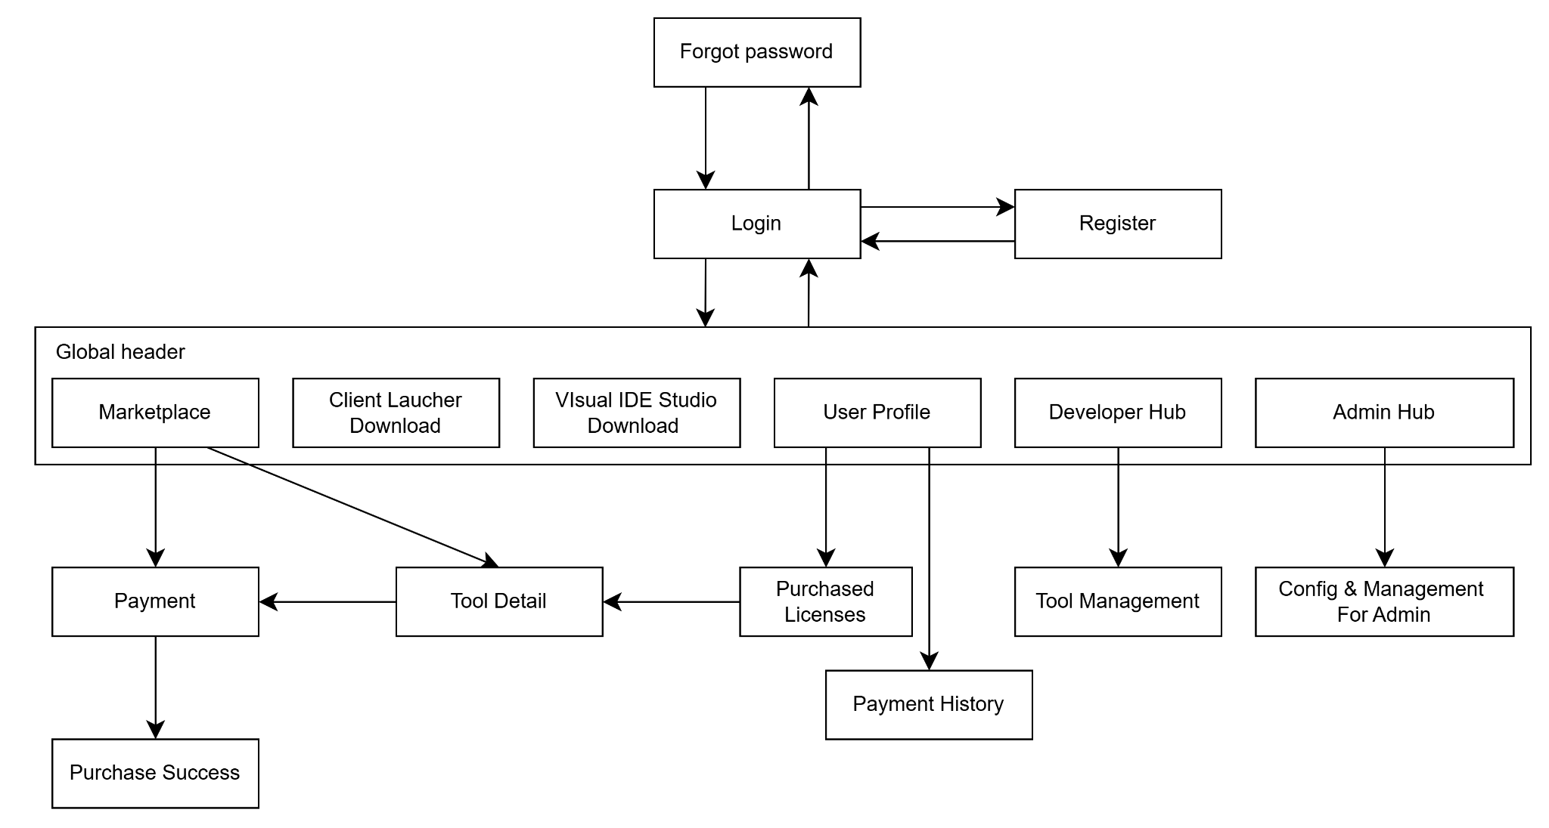

Screen List
# | Screen Name | Feature | Description
1 | Login | Authentication | Allows any user to authenticate and reach their role-specific area of the system
2 | Register | Authentication | Allows a new Candidate to create their own account
3 | Forgot password | Authentication | Allows registered user to reset password
4 | Marketplace | Marketplace | Allows any user to search for tools and buy tools
5 | Payment | Marketplace | Allows any user to pay for chosen license of a tool
6 | Purchase success | Marketplace | Let users know successful purchase
7 | Tool detail | Marketplace | Allow any user to view detail description of tool and provided licenses
8 | Client launcher download | Download | Allows any user to view general information of Laucher app and download app
9 | Visual IDE studio download | Download | Allows any user to view general information of IDE app and download app if having desire to create tools
10 | User Profile | Profile | Allows users to update their profile
11 | Purchased licenses | Marketplace | Allows users to view their bought licenses
12 | Payment history | Transaction | Allows users to view their transactions with marketplace
13 | Developer hub | Dashboard | Allows user with role Developer to view statistics of their uploaded tools
14 | Tool management | Tool Management | Allows user with role Developer to update information of their tools and licenses
15 | Admin hub | Dashboard | Allows user with role Admin to view statistics of web
16 | Config & Management for Admin | Management | Allows user with role Admin to config and manage web

5.1.2 Client Launcher

Screen Flow
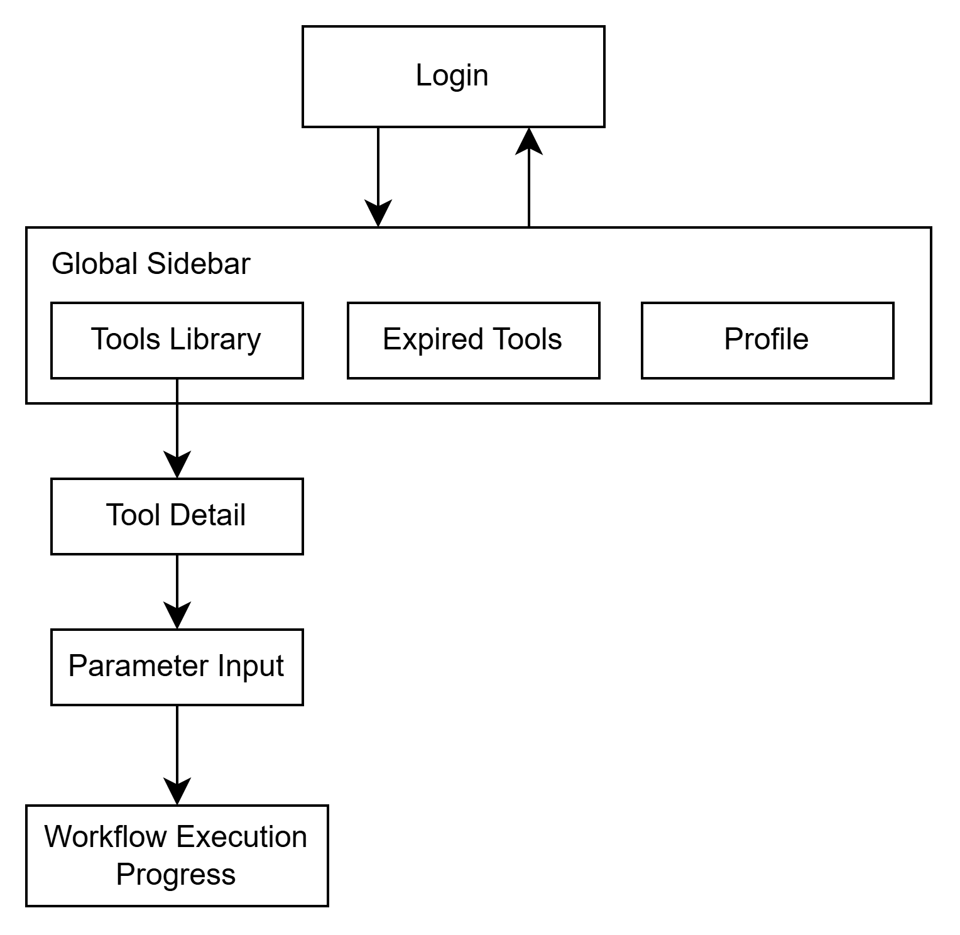

Screen List
# | Screen Name | Feature | Description
1 | Login | Authentication | Allows any user to authenticate and reach their role-specific area of the system
2 | Tool Library | Tool Library | Allows users to view and access tools with valid licenses
3 | Expired Tools | License Management | Allows users to view tools with expired licenses and re-purchase their licenses if available
4 | Profile | Profile | Allows users to view and update profile
5 | Tool Detail | Tool Execution | Allows users to view detail description of tool, download and run it
6 | Parameter Input | Tool Execution | Allows users to provide required parameters before running a tool
7 | Workflow Execution Progress | Tool Execution | Displays real-time execution progress, including completed, running, and pending workflow steps

5.1.3 Visual IDE Studio
- Screen Flow
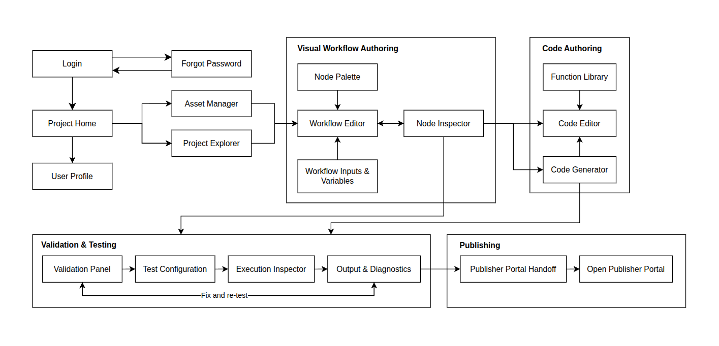
- Screen List
# | Screen Name | Feature | Description
1 | Login | Authentication | Allows a registered user to authenticate and access the A2MaTeX Studio.
2 | Forgot Password | Authentication | Allows a registered user to reset their password when they cannot access their account.
3 | Project Home | Project Management | Allows users to create, open and manage automation projects.
4 | User Profile | Profile | Allows users to view and update their account information.
5 | Asset Manager | Asset Management | Allows users to manage project resources such as images, OCR resources, icons and other assets.
6 | Project Explorer | Project Management | Displays project files, workflows and resources of the current automation project.
7 | Node Palette | Visual Workflow | Displays available workflow nodes that users can add to the workflow.
8 | Workflow Editor | Visual Workflow | Allows users to visually create and edit automation workflows by adding and connecting nodes.
9 | Workflow Inputs & Variables | Workflow Configuration | Allows users to define and manage workflow inputs, variables and data used during execution.
10 | Node Inspector | Node Configuration | Allows users to configure the parameters and properties of a selected workflow node.
11 | Function Library | Code Authoring | Displays predefined A2MaTeX automation functions that can be used in the Code Editor.
12 | Code Editor | Code Authoring | Allows users to write and edit automation code using functions provided by A2MaTeX.
13 | Code Generator | Code Authoring | Generates automation code based on workflow or node configuration to support code-based development.
14 | Validation Panel | Validation | Displays validation results and identifies errors in workflow structure, node configuration or code before testing.
15 | Test Configuration | Runtime Testing | Allows users to configure the Runtime Agent, target device and required parameters before running a test.
16 | Execution Inspector | Runtime Testing | Displays the execution state of the current workflow or test run.
17 | Output & Diagnostics | Runtime Testing | Displays runtime logs, execution results, errors and diagnostic information.
18 | Publisher Portal Handoff | Publishing | Allows users to open the current project in the Publisher Portal after completing development and testing.
19 | Open Publisher Portal | Publishing | Opens the corresponding project on the Web Publisher Portal for self-review and submission.

5.2 External API Inventory
[Fill details of each external API into the table with the columns and sample data as below]
# | API Name | Calling Path | Description
1 | Employee sync API | HRM System → TalentHub | allows an external HR management system to push employee records and automatically create Interviewer accounts
2 | Outbound webhook | TalentHub → External HRM | notifies an external system when a Candidate's status changes to HIRED

5.3 Background Job Inventory
[Fill details of each background job into the table with the columns and sample data as below]
# | Job Name | Group | Description
1 | Unlock expired locked accounts | Scheduled | Every 15 minutes
2 | Clean up old audit log entries | Scheduled | Daily at 2:00 AM

II. Use Case Specifications
[Provide specifications for the use cases (UCs) those are covered in the system. The UCs are grouped by the system features and even sub features. You just need to provide UC specifications for UCs involving in the main workflows (business processes) or the complex ones. Other UCs (i.e CRUD or data-viewing UCs) are simple, and you just need to refer the descriptions in the Functional Requirement (part III) below)]

1. <<Feature Name1>>

1.1 UC Name1
Primary Actors |  | Secondary Actors
Description
Preconditions
Normal Flow
Alternative Flows
Postconditions

Primary and Secondary Actors
An actor is a person or other entity external to the software system being specified who interacts with the system and performs use cases to accomplish tasks. Name the primary actor that will be initiating this UC and any other secondary actors who will participate in completing execution of the UC.
Description
Provide a brief description of the reason for and outcome of this use case, or a high-level description of the sequence of actions and the outcome of executing the use case. The description can be in the form of a user story (As a <type of user>, I want <some goal> so that <some reasons>)
Preconditions
List any activities that must take place, or any conditions that must be true, before the use case can be started.
Normal Flow
Provide a description of the user actions and corresponding system responses that will take place during execution of the use case under normal, expected conditions.
Alternative Flows
Describe below two information if any:
- Other successful usage scenarios that can take place within this use case. State the alternative flow, and describe any differences in the sequence of steps that take place.
- Any anticipated error conditions that could occur during execution of the use case and how the system is to respond to those conditions.
Postconditions
- Describe the state of the system at the successful conclusion of the use case execution.

1.2 Login System
Primary Actors | Customer | Secondary Actors | None
Description | As a user, I want to be able to log into the system so that I can use the system’s authenticated features and access my personalized account.
Preconditions | User account has been created & authorized
Normal Flow | Login System  - User clicks Login button from the page header or accesses an authenticated feature (from a link or type the page URL directly into the address bar)  - System show the User Login screen  - User types in the login details (email, password)  - User clicks the Login button  - System validates the login details (GBR-04, GBR-05)  - System allows user to access  - System tracks user’s success login to the Activity Log  - System directs user to the Home Page (or the previous calling page if any)
Alternative Flows | Step 2.1_Google Login  - User clicks Google Login button to login system using Google account  - System redirects the user to the Google’s Login screen  - User types in the Google account details and chooses to login  - Google validates user’s login information successfully and redirect him/her back to the system  - Return to step 5 of normal flow.  Step 4_System can’t authenticate the user  User can’t be authenticated & get relevant error message in one of below cases  - He/she leaves the Email and/or Password field blank (MSG10)  - Input Email or Password are incorrect (MSG09)  - Input Email/Password are correct but email has not been verified (MSG11)  - The user account is blocked / inactive (MSG12)  If user inputs wrong logging-in details 5 times continuously, system will lock his/her account in 30 minutes (with relevant warning message - MSG13)
Postconditions | - User logs in the system successfully  - The system tracked successful login into the Activity Log

1.3 UC Name2
…

2. Xyz Feature
…

III. Functional Requirements
[Provide descriptions about the system’s functions/screens. The screens are grouped by the system features, and even sub-features if needed, and you need to provide the screen layouts (mock-up screens) and relevant specifications if needed. Other functions (background jobs, external APIs) are provided in the last two sections (Background Job Inventory, External API Inventory)]

1. Authentication

1.1 User Register

1.1.1 Register screen
[Content #1: UI layout (Wireframe or Mockup for the screen]
[Content #2: brief descriptions of the screen/function, mapped to the relevant use cases]
[Content #3: provide further descriptions for the screen’s components/fields using table format below]
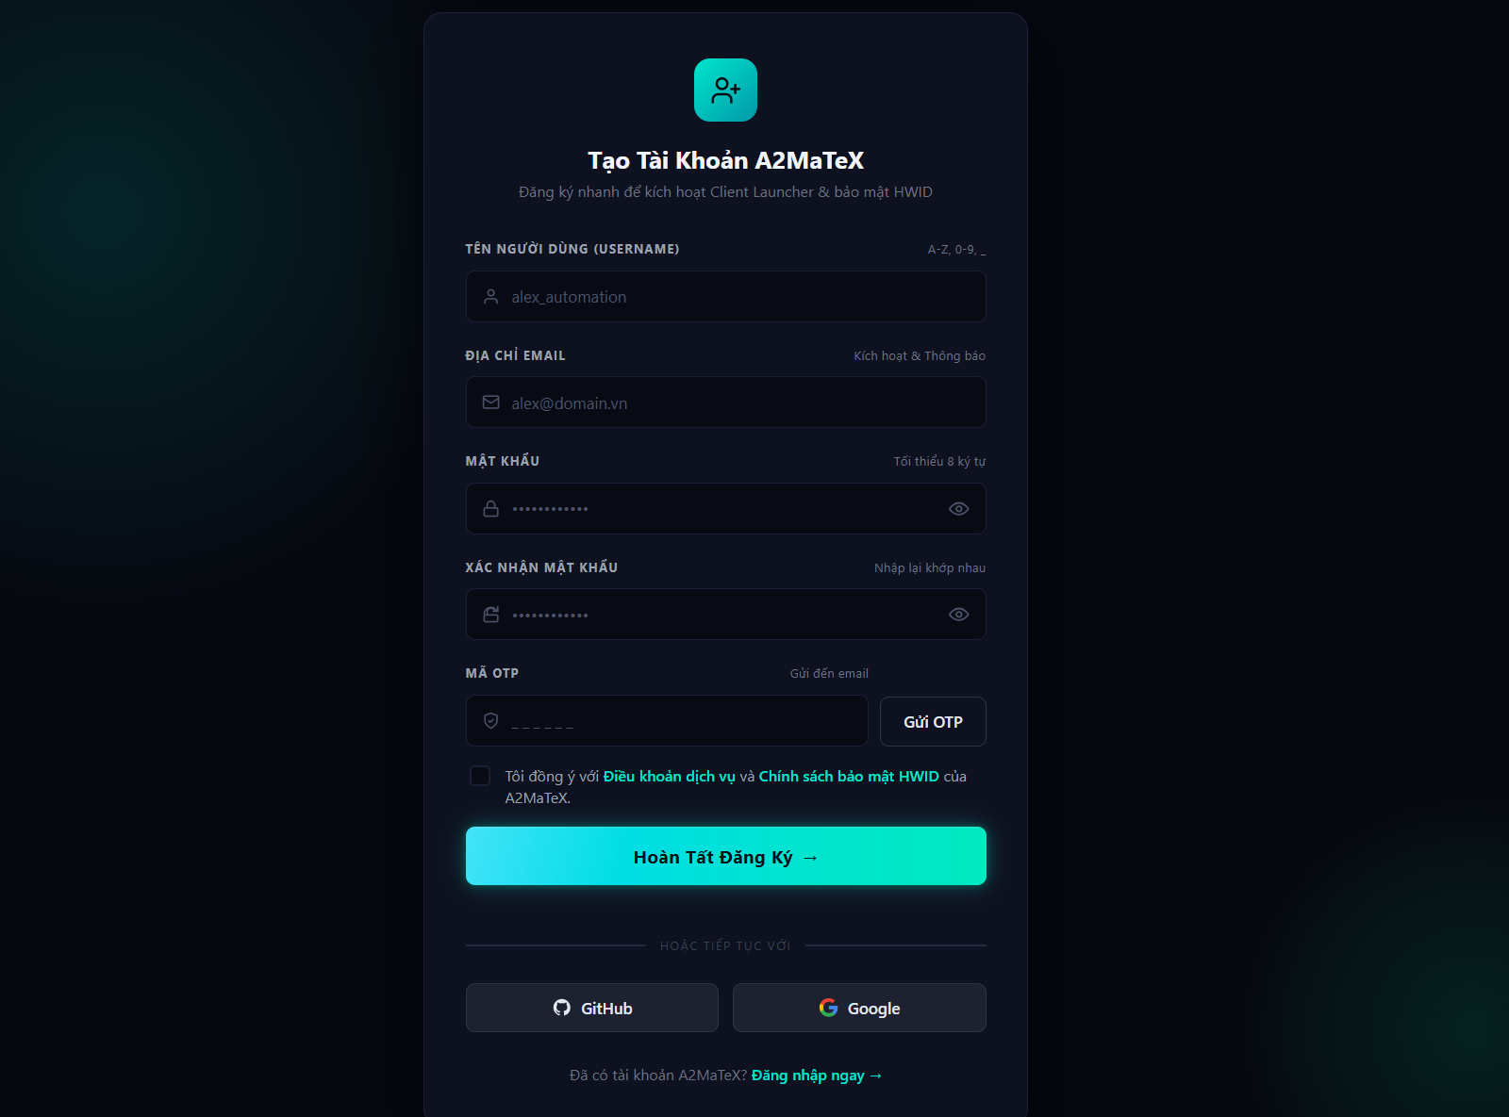
This screen allows any new user to:
- Register: register new account using username, email, password

Field Name | Description
Username | Data type: string, min length of 1 characters, max length of 100 characters
Email | Data type: email format
Password | Data type: string, min length of 6 characters, max length of 100 characters
Retype password | Data type: string, min length of 6 characters, max length of 100 characters
OTP code | Data type: digit string, length is 6 characters

1.2 User Login
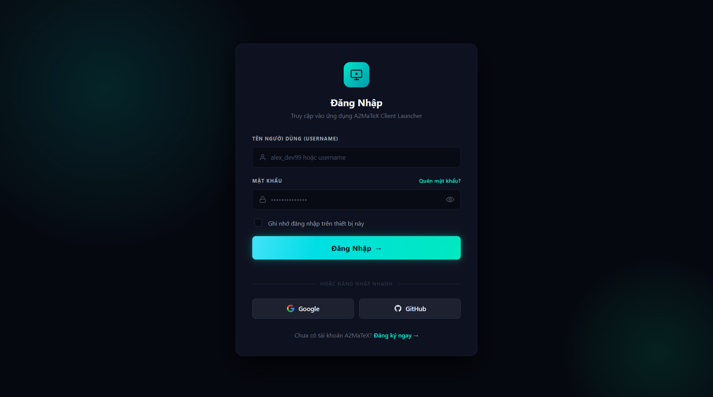
This screen allows registered users to:
- Login: login into system using registered accounts
Field Name | Description
Username | Data type: string, min length of 1 characters, max length of 100 characters
Password | Data type: string, min length of 6 characters, max length of 100 characters

2. Marketplace

2.1 Market
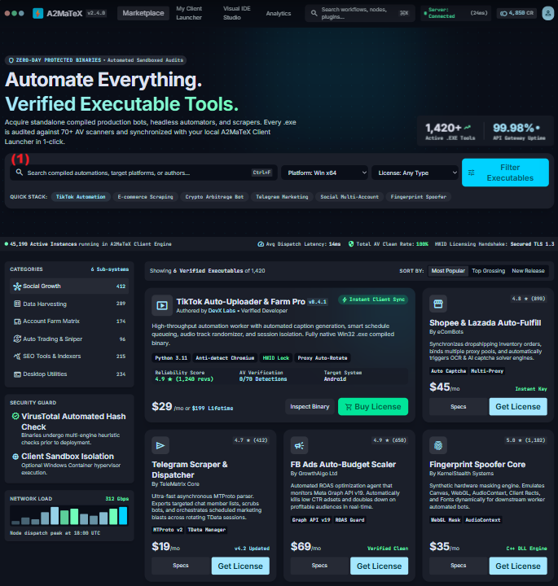
This screen allows any new user to:
- View outstanding tools
- Search for tool by names, authors, licenses, platforms
- Filter tools by categories
- Sort by Most Popular, Top Grossing, New Release
- Buy tool right away
Field Name | Description
(1) | Data type: string
Platform | Initial value: Win x64  Type: Select/Dropdown
License | Initial value: Any type  Type: Select/Dropdown
Quick stack | Initial value: Null  Type: Radio button (multi-select)
Sort by | Initial value: Most Popular  Type: Radio button
Categories | Initial value: Social Growth  Type: Radio button

2.2 Tool Detail
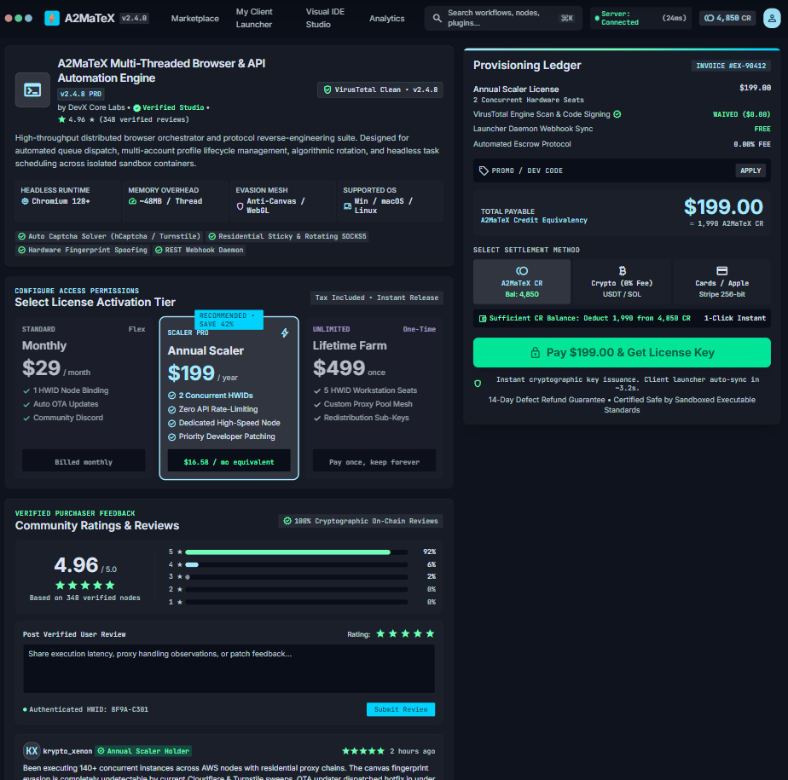
This screen allows any new user to:
- View details of a tool
  - Detail description
  - Licenses and price
  - Ratings and comments
- Purchase for tool
Field Name | Description
Select License Activation Tier | Initial value: Recommend License  Type: Radio button
Promo/Dev Code | Data type: String, length is 6
Select Settlement Method | Initial value: QR code  Type: Radio button
Rating | Initial value:5 stars  Type: Radio button
User Review | Data type: String

3. Publish Tool

3.1 Config&Submit Tool
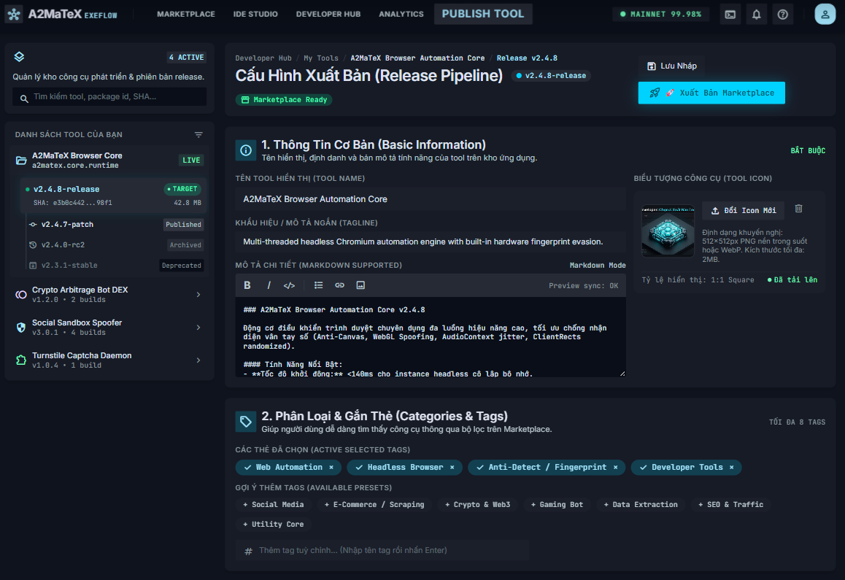
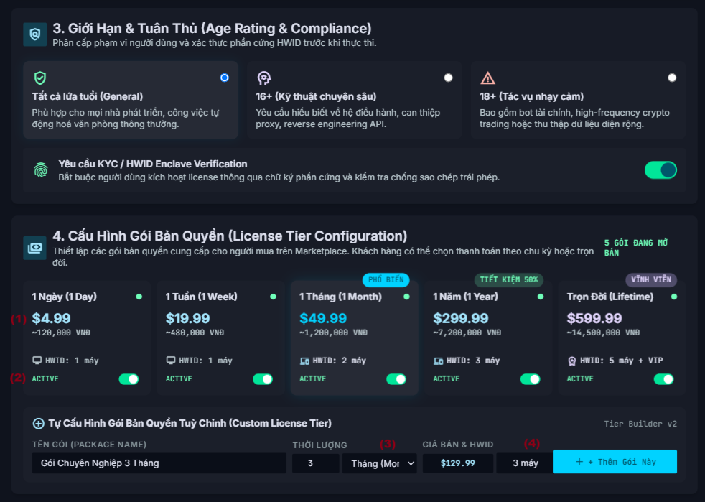
This screen allows Publisher to:
- Select version of tool that he wants to publish
- Write detail description about tool
- Config tool licenses
- Submit tool for admin’s approve
Field Name | Description
Search | Data type: String
Tool Name | Data type: String, min length is 1 and max length is 200 characters
Tagline | Data type: String, max length is 200 characters
Detail description | Data type: String
Tool Icon | Data type: Image upload, recommended ratio: 1x1  Max size: 2MB
Categories & Tags | Initial value: Null  Type: Radio button (multi-select)
Custom tag | Data type: String, min length is 1, max length is 50
Age rating and compliance | Initial value: General  Type: Radio button
(1) | Data type: positive float
(2) | Initial value: ACTIVE  Click to change the status of this license to INACTIVE
Package Name | Data type: String, max length is 30 characters
Duration | Data type: Positive integer
(3) | Initial value: Month  Click to view all time units (day, week, month, year)
Price | Data type: Positive float
(4) | Data type: Positive integer  Initial value: 1

3.2 Approve Tool
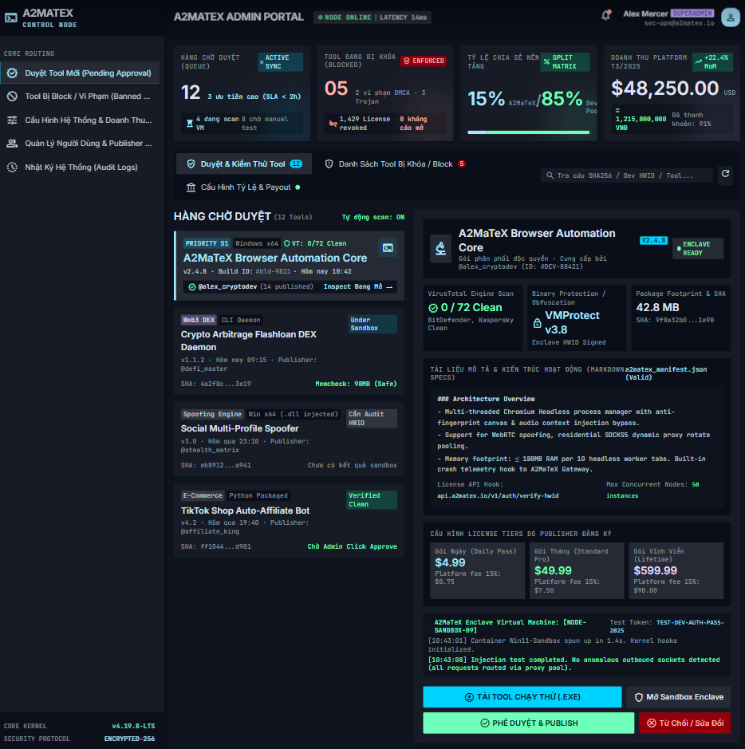
This screen allows Admin to:
- View general information of system
- View detail of tools which are waiting for being published
- Download tool
- Approve/Reject tools
Field Name | Description
Search | Data type: String

3.3 Block Tool
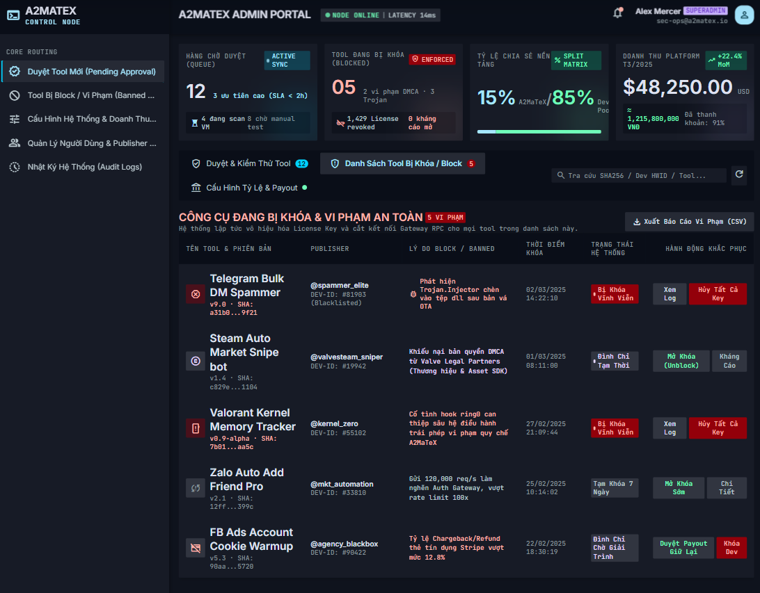
This screen allows Admin to:
- View general information of system
- View tools which were blocked
- Unlocked tools
- Cancel all keys of tools
Field Name | Description
Search | Data type: String

4. Run Tool on Desktop

4.1 View & Download Tool
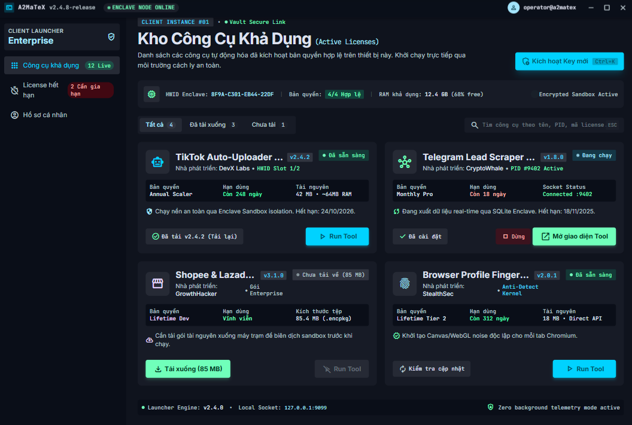
This screen allows Customer to:
- View all purchased tools that has valid licenses
- Download purchased tools
- Run downloaded tools
Field Name | Description
Search | Data type: String

4.2 Config & Run Tool
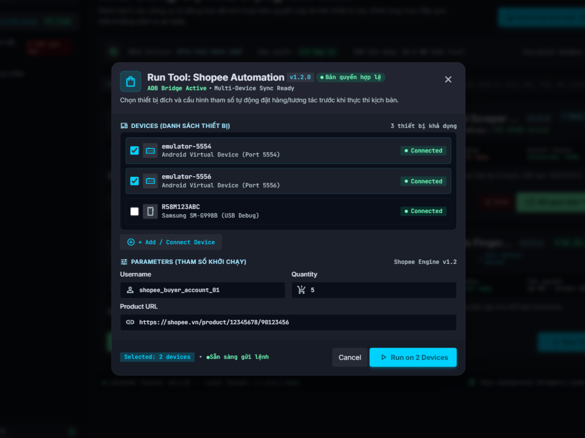
This screen allows Customer to:
- Choose target devices
- Enter parameters for runtime
- Run tools on selected android devices
Field Name | Description
Devices | Type: Ratio (Multiple select)
Parameters | Based on config of each tools, parameters will be different

4.3 Monitor Running Tool & Devices
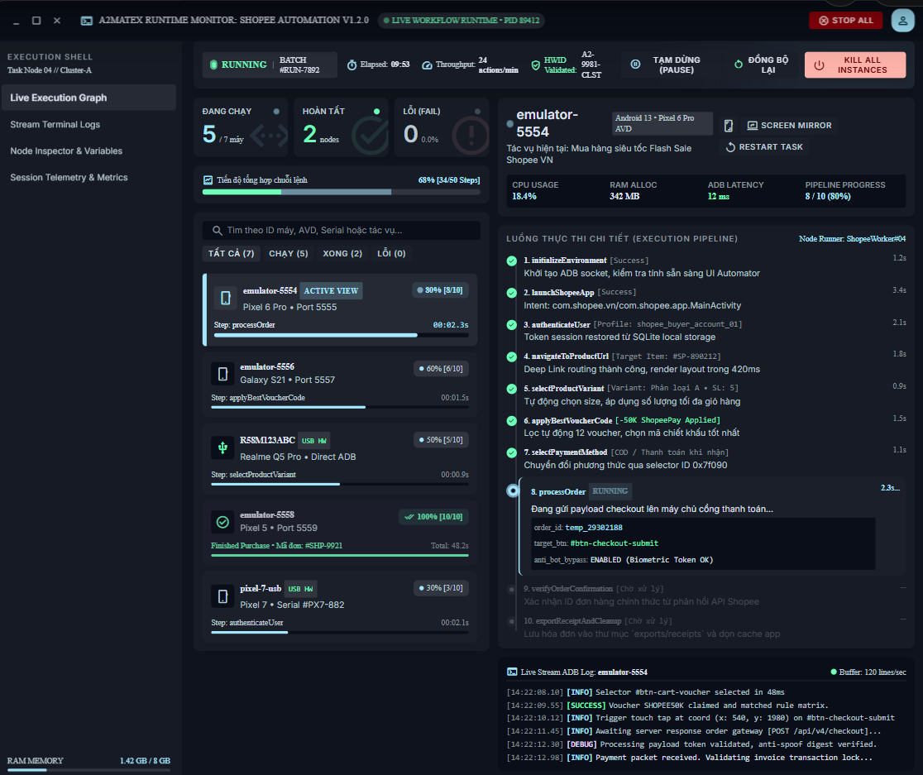
This screen allows Customer to:
- Monitor running tool and devices
- Pause devices/tool
- Restart task
Field Name | Description
Search | Data type: String

10. System Administration

10.1 Revenue Sharing & Payment
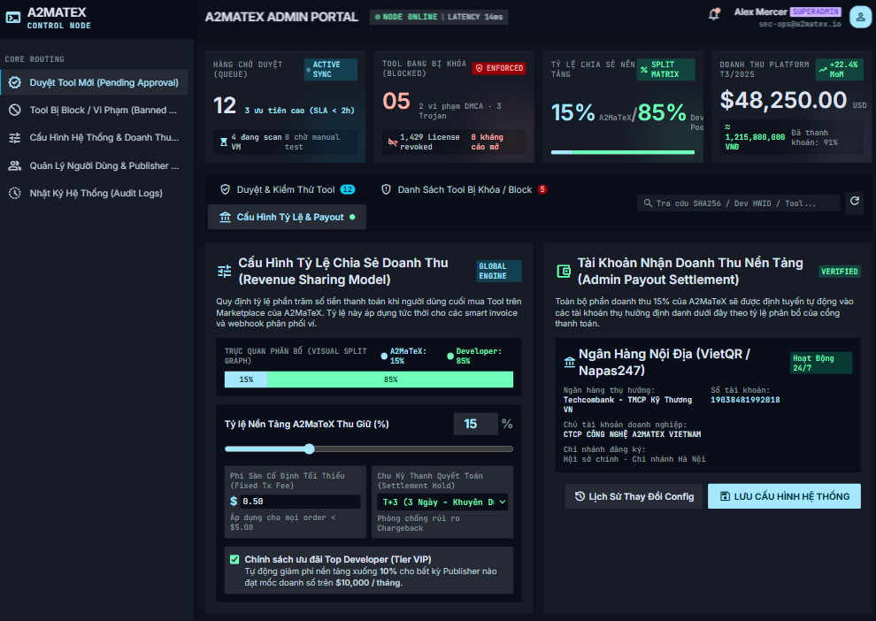
This screen allows Admin to:
- View general information of system
- View history of config change
- Manage revenue sharing model between system and Publishers
- Manage payment information of system
Field Name | Description
Revenue-sharing percentage | Data type: Positive float
Minimum platform fee | Data type: Positive float
Settlement Hold | Type: Select/Dropdown  Initial value: T+3
Bank Name | Type: Select/Dropdown
Bank Account Name | Type: Digit string
Bank Account Number | Type: String
Bank Branch | Type: Select/Dropdown

5. Background Job Inventory

5.1 Unlock Expired Locked Accounts (JOB-01)
Trigger: Scheduled — every 15 minutes
Purpose: Automatically unlocks accounts that were locked after failed sign-in attempts, once the lockout duration has elapsed
Processing steps:
- Find all accounts with status = Locked where the lockout timestamp is more than 10 minutes ago.
- For each account found: reset the failed sign-in count to zero, set status back to Active.
- Log the number of accounts unlocked in this run.
Failure behavior:
Scenario | System behavior
Database unreachable | Job retries up to 3 times with 30-second intervals. If still failing, logs a critical error. Accounts remain locked until the next successful run.
No locked accounts found | Job completes immediately with no action — this is normal and expected.

5.2 Clean Up Old Audit Log Entries (JOB-02)
Trigger: Scheduled — daily at 2:00 AM
Purpose: Removes audit log entries older than the configured retention period to prevent unbounded database growth.
Processing steps:
- Determine the configured log retention period (default: 90 days).
- Find all audit log entries with a timestamp older than the retention threshold.
- Delete the old entries in batches of up to 5,000 records per run — to avoid locking the database for an extended period.
- If records remain after one batch, schedule the next batch to run 5 minutes later rather than deleting everything at once.
- Log the total number of entries deleted and the number of batches processed.
Failure behavior:
Scenario | System behavior
Database timeout during delete | Current batch rolled back. Job logs a warning. Tries again at the next scheduled time. No data corruption.
Retention period not configured | Job uses default of 90 days and logs a warning that the setting was not found.

6. External API Inventory

6.1 HTTP Method: URL pattern (API-ID)
URL | HTTP method: URL pattern
Purpose | Purpose in one plain-language sentence
Caller | Who the caller is (which external system)
Auth | Authentication requirement (yes/no + type)

6.2 VnPay Webhook (API-02)
URL | POST: /api/v1/commerce/payment/webhook/vnpay
Purpose | Receives payment confirmation (IPN) from VNPay; triggers access grant creation
Caller | VNPay payment gateway
Auth | HMAC-SHA512 signature validation

6.3 SePay Webhook (API-03)
URL | POST: /api/v1/commerce/payment/webhook/sepay
Purpose | Receives payment confirmation from SePay; triggers access grant creation
Caller | SePay payment gateway
Auth | HMAC signature validation

IV. Non-Functional Requirements

1. External Interfaces
[This section provides information to ensure that the system will communicate properly with users and with external hardware or software/system elements.]

2. Quality Attributes
[List all the required system characteristics (quality attributes) specification. Some of the possible attributes are provided with the guide/descriptions are mentioned here]

2.1 Usability
[This section includes all those requirements that affect usability. For example, specify the required training time for a normal user and a power user to become productive at particular operations specify measurable task times for typical tasks or base the new system’s usability requirements on other systems that the users know and like specify requirement to conform to common usability standards, such as IBM’s CUA standards Microsoft’s GUI standards]

2.2 Performance
[The system’s performance characteristics are outlined in this section. Some samples are as below]
Requirement | Target | Condition
Page load time | Any page loads within 2 seconds | Up to 100 users active simultaneously
Form submission response | System acknowledges within 2 seconds | Up to 100 users active simultaneously
Maximum simultaneous users | System remains fully functional for up to 100 users | Single server deployment

2.3 Security
[State the requirement of security, not the implementation mechanism. Some samples are as below]
Requirement | Description
Authentication required | Every page and action other than the sign-in page, registration page, and public job listings requires the user to be signed in.
Password protection | Passwords must never be stored in a form that a person or program can read.
Account lockout | After a defined number of consecutive failed sign-in attempts, the account is temporarily locked. Threshold and duration defined in TDS §4.
CV file access | CV files may only be accessed by users with permission to view the associated Application. The system verifies permission on every access.

V. Requirement Appendix
[Provide business rules, common requirements, or other extra requirements information here]

1. Business Rules
[Provide common business rules that you must follow. The information can be provided in the table format as the sample below]
GBR-ID | Rule Statement | Applies To | Rationale | Enforced By
GB-01 | Status changes are one-way and permanent. No status may be reverted to a previous value. | Job posting status, Application status, Interview status | Prevents data integrity loss; maintains clear audit trail. | The system automatically on every status change
GB-02 | Internal Notes are never visible to Candidates, regardless of how they access the system. | All views accessible to Candidates | Allows HR to write candid internal assessments. | The system automatically on every page and data request
GB-03 | CV files may only be accessed by staff with permission to view the associated Application. Access verified on every download. | All CV file access | Protects Candidates' personal data from unauthorised access. | The system automatically on every file access request
GB-04 | When a sign-in fails, the message must not reveal whether the username exists or the password was wrong. | Sign-in | Prevents attackers from discovering valid usernames. | The system automatically on every failed sign-in
GB-05 | A deactivated account cannot sign in, regardless of password correctness. | Sign-in | Ensures departed staff lose access immediately. | The system automatically on every sign-in attempt
GB-06 | An Interviewer may only access Applications they have been explicitly assigned to. | Application access | Maintains pipeline confidentiality; prevents evaluation bias. | The system automatically on every Application access request

2. System Messages
# | Message code | Message Type | Context | Content
1 | MSG01 | In line | There is not any search result | No search results.
2 | MSG02 | In red, under the text box | Input-required fields are empty | The * field is required.
3 | MSG03 | Toast message | Updating asset(s) information successfully | Update asset(s) successfully.
4 | MSG04 | Toast message | Adding new asset successfully | Add asset successfully.
5 | MSG05 | Toast message | Confirming email of asset hand-over is sent successfully | A confirmation email has been sent to {email_address}.
6 | MSG08 | In red, under the text box | Input value length > max length | Exceed max length of {max_length}.
7 | MSG09 | In line | Username or password is not correct when clicking sign-in | Incorrrect user name or password. Please check again.
8 | ..

3. Other Requirements
…

